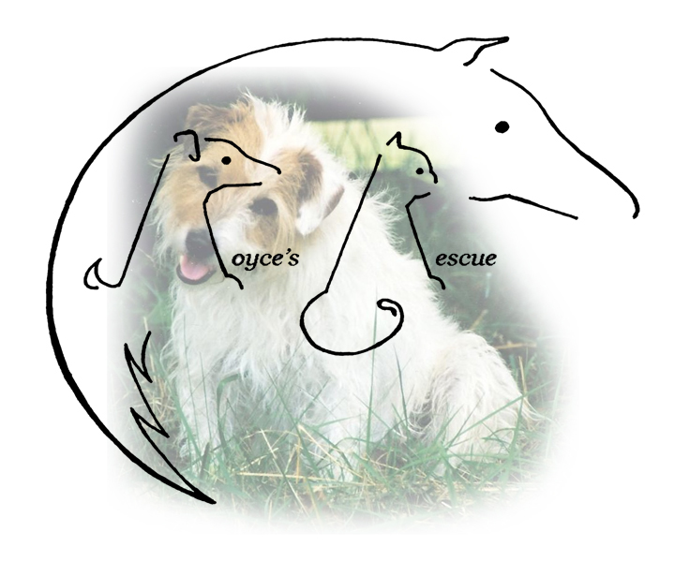
Royce’s Rescue
c/o Linda Satterfield
374 Worthington Mill Road
Richboro, PA 18954
Cell: 215-801-6398
linsatter@verizon.net

ADOPTED CAT/DOG APPLICATION

CAT/DOG ______________ BREED ______________________ SEX ____________ FIXED ______________________

NAME ______________________________ AGE in MONTHS _____________ COLOR _________________________

DISTINGUISHING MARKS __________________________________________________________________________

I, ________________________________, hereafter referred to as the adopter; hereby agree that the above described animal is being adopted by me solely as a pet for myself and/or my immediate family. I agree that I will not sell, give away or otherwise dispose of said animal to any person(s), dealer, retailer, auction, institute or any other entity for any reason. If at a later date I am unable or unwilling to keep this pet, I agree to first contact Royce’s Rescue and give them the option to reclaim said pet at no charge.

I hereby agree to care for the above described pet in a humane and responsible manner and to provide it with clean and adequate shelter, food, water, and veterinary care. I further agree that said pet shall reside inside my home and shall not be allowed to roam freely.

The animal must be spayed / neutered.

I hereby agree that this pet shall wear a collar or harness with identification tags at all times. (Dogs only)

I hereby agree that the adoption fee of $ _____________ is not refundable after a trial period of 10 days.

I hereby understand and agree that the current owner makes no representations or warranties, expressed or implied, about the above mentioned animal’s temperament and is hereby absolved from any liability for future damages or injuries caused by said animal. I also understand and agree that the current owner further gives no guarantees, expressed or implied, of the suitability of the animal to the adopter and/or his family.

ADOPTER’S NAME ____________________________________________________________________________________________

ADDRESS _____________________________________________________________________________________________________

CITY/STATE __________________________________ ZIP CODE _____________ PHONE ________________________________

Vet Reference (Please use your vet, name and phone number) _________________________________________________________

I certify that all statements made by me on this adoption agreement are true and correct. I agree that the current owner has the right to confiscate the above described animal in the event that any statements made by me are found to be false and/or my check for the adoption fee is returned for insufficient funds.

__________________________________________________________________________________ DATE ________________________________
ADOPTER’S SIGNATURE

__________________________________________________________________________________ DATE ________________________________
Linda Satterfield

Adopter is defined here as the person who accepts for adoption the above described animal.

