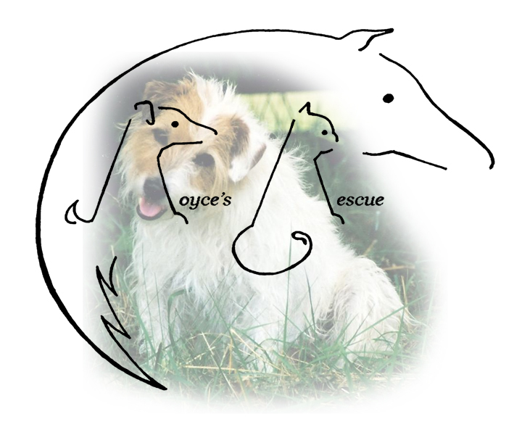
Royce’s Rescue
c/o Linda Satterfield
374 Worthington Mill Road
Richboro, PA 18954
Cell: 215-801-6398
linsatter@verizon.net
1

ADOPTED DOG/CAT APPLICATION

DOG/CAT ___________ BREED ______________________ SEX ____________ FIXED __________

NAME _______________________________ DOB ________________ COLOR __________________

DISTINGUISHING MARKS ____________________________________________________________

2
I, ___________________________, hereafter referred to as the adopter; hereby agree that the above described animal is being adopted by me solely as a pet for myself and/or my immediate family. I agree that I will not sell, give away or otherwise dispose of said animal to any person(s), dealer, retailer, auction, institute or any other entity for any reason. If at a later date I am unable or unwilling to keep this pet, I agree to first contact Royce’s Rescue and give them the option to reclaim said pet at no charge.

I hereby agree to care for the above described pet in a humane and responsible manner and to provide it with clean and adequate shelter, food, water, and veterinary care. I further agree that said pet shall reside inside my home and shall not be allowed to roam freely.

The animal must be spayed / neutered.

I hereby agree that this pet shall wear a collar or harness with identification tags at all times. (Dogs only)

I hereby agree that the adoption fee of $ __________ is not refundable after a trial period of 14 days.

I hereby understand and agree that the current owner makes no representations or warranties, expressed or implied, about the above mentioned animal’s temperament and is hereby absolved from any liability for future damages or injuries caused by said animal. I also understand and agree that the current owner further gives no guarantees, expressed or implied, of the suitability of the animal to the adopter and/or his family.

ADOPTER’S NAME ____________________________________________________________________

ADDRESS _____________________________________________________________________________

CITY/STATE ________________________________ ZIP CODE _________ PHONE ______________

Reference (Please use your vet, name and phone number) _____________________________________

I certify that all statements made by me on this adoption agreement are true and correct. I agree that the current owner has the right to confiscate the above described animal in the event that any statements made by me are found to be false and/or my check for the adoption fee is returned for insufficient funds.

__________________________________________________________________ DATE _____________________________
ADOPTER’S SIGNATURE

__________________________________________________________________ DATE _____________________________
Linda Satterfield

Adopter is defined here as the person who accepts for adoption the above described animal.

